**Digital Nurture 4.0 Deep Skilling - Java FSE**

**Week 7 – React 12_ReactJS_HOL HandsOn**

Create a React Application named “ticketbookingapp” where the guest user can browse the page where the flight details are displayed whereas the logged in user only can book tickets.

The Login and Logout buttons should accordingly display different pages. Once the user is logged in the User page should be displayed. When the user clicks on Logout, the Guest page should be displayed.

**CODE:**

**App.js**

import { useState } from 'react';

import User from './components/User';

import Guest from './components/Guest';

import Login from './components/Login';

import Logout from './components/Logout';

function App() {

const [isLogIn, setIsLogIn] = useState(false);

const handleLogin = () => setIsLogIn(true);

const handleLogout = () => setIsLogIn(false);

let page;

if (isLogIn) {

page = <User />;

} else {

page = <Guest />;

}

return (

<div>

<h1>Flight Booking Portal</h1>

{page}

{

isLogIn

? <Logout onClick={handleLogout} />

: <Login onClick={handleLogin} />

}

</div>

);

}

export default App;

**reportWebVitals.js**

const reportWebVitals = onPerfEntry => {

if (onPerfEntry && onPerfEntry instanceof Function) {

import('web-vitals').then(({ getCLS, getFID, getFCP, getLCP, getTTFB }) => {

getCLS(onPerfEntry);

getFID(onPerfEntry);

getFCP(onPerfEntry);

getLCP(onPerfEntry);

getTTFB(onPerfEntry);

});

}

};

export default reportWebVitals;

**setuptest.js**

import '@testing-library/jest-dom';

**AppTest.js**

import { render, screen } from '@testing-library/react';

import App from './App';

test('renders learn react link', () => {

render(<App />);

const linkElement = screen.getByText(/learn react/i);

expect(linkElement).toBeInTheDocument();

});

**OUTPUT:**

**Guest.png**

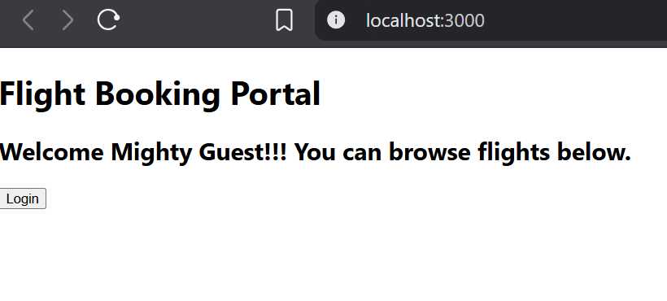

**User.png**

